Psychology 602A, Spring 2021 Exam III

Part I (30). ___

Part II (60). ___

Intro q’s (10). ___

Total: ___

Name: IBRAHIM SANUSI__

Analysis you’re most likely to use: _____________Analysis of Variance_____ __   (5 points)

Statistical Software you’re most likely to use: ______SPSS ____________   (5 points)

Part I. Conceptual Matters (short answer 30 points)

1. What is the advantage of performing an ANOVA over multiple t-tests?

Every time you conduct a t-test there is a chance that you will make a Type I error. This error is usually 5%. By running two t-tests on the same data you will have increased your chance of "making a mistake" to 10%. The formula for determining the new error rate for multiple t-tests is not as simple as multiplying 5% by the number of tests. However, if you are only making a few multiple comparisons, the results are very similar if you do. As such, three t-tests would be 15% (actually, 14.3%) and so on. These are unacceptable errors.

An ANOVA controls for these errors so that the Type I error remains at 5% and you can be more confident that any statistically significant result you find is not just running lots of tests.

By the way, Type 1 error, in statistical hypothesis testing, is the error caused by rejecting a null hypothesis when it is true. Type I error is equivalent to false positive. It is a false rejection of a true hypothesis.

<https://statistics.laerd.com/statistical-guides/one-way-anova-statistical-guide-2.php>

Also,

The ANOVA has the advantage in that it can do multiple comparisons at one time and allows you to avoid ‘inflated’ α levels.

What does a significant ANOVA allow you to say?

A significant ANOVA allow me to say that, there is / there are statistically significant differences between the means of three or more independent (unrelated) group of variables that are unlikely to occur by chance.

Specifically, it allows me to reject the null hypothesis that:

H0 = µ1 = µ2 = µ3 = ……… = µk

where µ = group mean and k = number of groups. It allows me to accept the alternative hypothesis (HA), which is that there are at least two group means that are statistically significantly different from each other.

However, at this point a significant ANOVA is an omnibus test statistic and I cannot tell which specific groups were statistically significantly different from each other, only that at least two groups were. To determine which specific groups differed from each other, I will need to use a post hoc test.

<https://statistics.laerd.com/statistical-guides/one-way-anova-statistical-guide.php>

Bonus: When might using contrasts be preferable to running an ANOVA?

* If you are interested in specific hypotheses, then using preplanned contrasts can give you more power to detect the difference(s) you are interested in.
* Contrasts are “sniper” or “spotlight” analyses that concentrate your analytical ‘power’ in specific places (analogous to ‘one tail’ tests).
* In cases where you do have specific hypotheses, contrasts can be used in place of the overall ANOVA.
* Contrasts is used when we want to test for more general hypotheses about population means.

1. Answer A or B

A. From a **practical standpoint**, what does a Factorial design/analysis allow you to do (what is the main advantage of these designs/analyses)?

A factorial design allows me to find the effect of several factors and the interactions between them using the same number of trials as are necessary to determine any one of the effects by itself with the same degree of accuracy.

What doesn’t this analysis/design allow you to do?

Factorial experiments are not designed to efficiently determine ‘optimal’ level of treatments or treatment combinations. Again, smaller studies (based on previous knowledge) may be more useful.

<https://psychology.illinoisstate.edu/jccutti/psych340/fall02/oldanovafiles/anova3.html>

B. From an **interpretation standpoint**, what does a Factorial design/analysis allow you to say about your data? What kinds of effects can you now discuss? What are potential limitations?

N/A, I answered path A

1. You find that your factorial analysis has yielded both main effects and interactions; how should you handle this joyous event in your results/discussion?

In the result session, I will report the findings of the main effects first and then the interactions. However, in my discussion session, I will start by talking about the interaction first before talking about the main effects.

What information do you use to help describe/interpret interactions?

The information of the simple main effects would be necessary to describe/interpret interactions. Because, when there is an interaction it mean there is one or more simple main effect that are not equivalent.

1. You perform a study (subject of your choice) that is a 2 x 3 between subjects (participants) design. You discover that your statistical program has become corrupted and can only compute one-way ANOVAs.

a) **how** would you analysis your factorial experiment with a single factor program?

In a 2x3 design there are two independent variables (say A and B). “A” has two levels, and “B” has three levels, and typically, there would be one dependent variable (say Y). A study that involves only one independent variable is called a single-factor design. A study with more than one independent variable is called a factorial design (i.e., a combination of two or more single factor design).

In this scenario, I would run one-way ANOVA on “A”, and then run another one-way ANOVA on “B” and finally, I will run one-way ANOVA on “A&B” accordingly. I will also find the effect size of each factor and their interaction.

b) What would be a reason **why** you might want to perform the analyses this way?

The reason been that, using factorial design will result in partitioning the variances of the 2 factors between groups ANOVA as shown in the figure below. Therefore, running ANOVA individual as described above will give the same result.

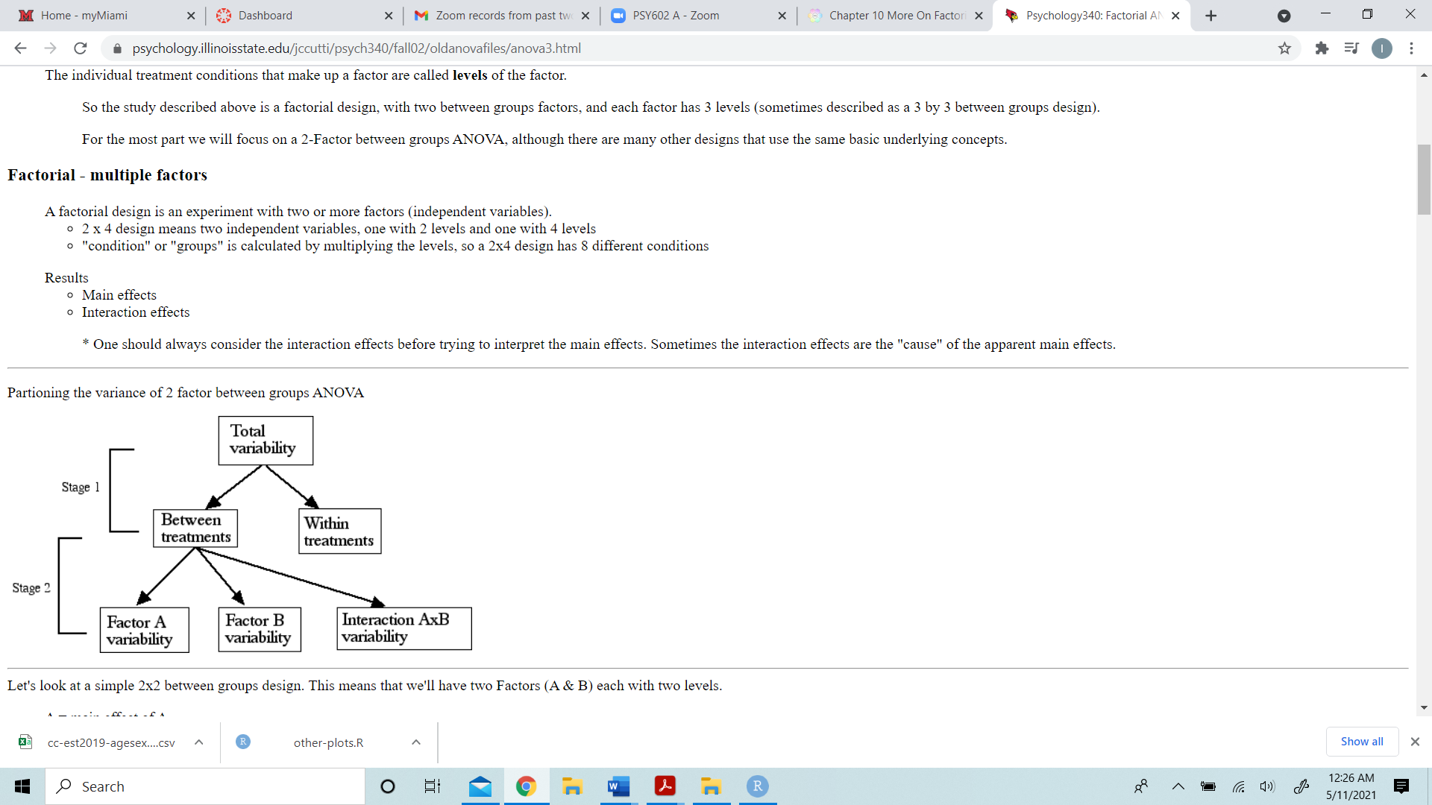

<https://psychology.illinoisstate.edu/jccutti/psych340/fall02/oldanovafiles/anova3.html>

1. MANOVA and ANCOVA both are designs that combine variance partitioning and regression, yet they are not identical – how do they differ in terms of treatment of the DV(s)?

A MANOVA (“Multivariate Analysis of Variance”) is used to determine whether or not there is a statistically significant difference between the means of three or more independent groups. Except, it uses two or more dependent variables (DV(s)).

An ANCOVA (“Analysis of Covariance”) is also used to determine whether or not there is a statistically significant difference between the means of three or more independent groups. Except, it uses only one dependent variable (DV).

How does the interpretation differ between these analyses?

Unlike MANOVA, an ANCOVA includes one or more covariates, which can help us better understand how a factor impacts a dependent variable (DV) after accounting for some covariate(s).

1. Like ANOVA, MANOVA and ANCOVA are pretty robust in the face of violations of assumptions. However, both are very sensitive to violations of linearity and the presence of outliers. Explain why this makes sense?

This makes senses for the following reason:

* Outliers can severely affect normality and homogeneity of variance.
* Deviations from linear relationships can reduce the benefit of adding the covariate (i.e., error reduction)
* If outliers are present, then the analysis of covariance may not be the most informative analysis available, and this could mean the difference between finding a significant difference between the treatment (group) means or not.
* Choosing an X variable that has no linear relation to Y is pointless: no reduction in variance will be achieved, and the power of the test will be reduced. However, the effect will not generally be serious unless the number of data points is small.
* If there is no linear relation between X and Y, then the analysis of covariance offers no improvement over the one-way analysis of variance in detecting differences between the group means.

Part II. Computation/Interpretation (60 points)

Questions 1 & 2:

Given the prevalence of soft drink machines on campus a researcher was interesting in finding out if consumption of these drinks had an impact on learning. The research examined three variables related to the drinks: carbonation, caffeine, and sweetener. The researcher was interested in whether different combinations of these factors had an influence on memory tasks. The researcher varied carbonation (present, absent), amount of caffeine (none, moderate, heavy), and type of sweetener used (sugar, ½ sugar ½ artificial, artificial). The researcher gave a group of students a novel text to read and remember while consuming the drinks. Later these students were given a recall test and the number of recall errors was recorded.

* Run a between groups factorial analysis on these data and interpret the results of the analysis.

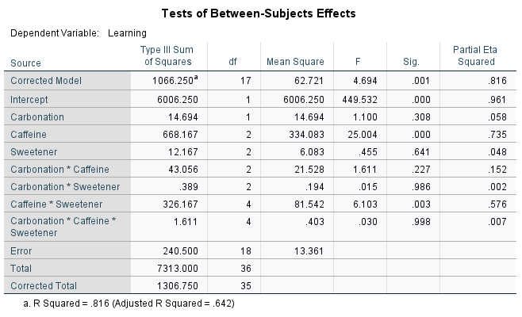

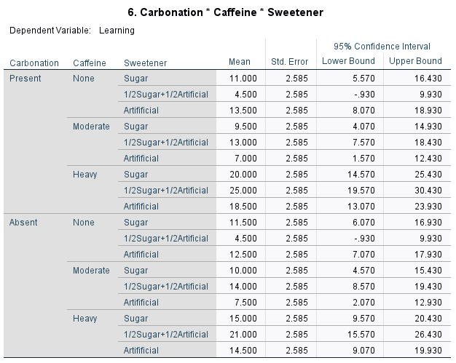

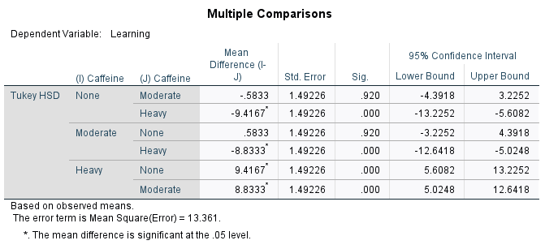

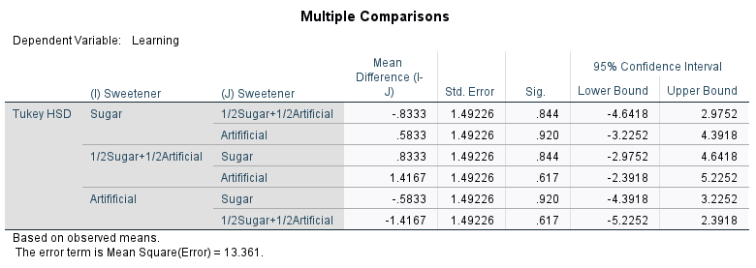

**Part 2: Question 1: Interpretation**

A factorial analysis was conducted to evaluate the impact of drinks carbonation, sweeteners and caffein on learning (recall). The means and standard deviations for the learning recall are presented in Table 2.1 below. The result of the analysis indicated a significant main effect for only caffeine, *F*(2,18) = 25.004, *p*(0.000) < 0.05, partial ɳ2 = 0.735, whereas, there were nonsignificant main effect for carbonation *p*(0.308) > 0.05 and sweetener *p*(0.641) > 0.05. In terms of interactions, there was significant interaction effect between caffeine and sweetener, *F*(4,18) = 6.103, *p*(0.003) < 0.05, partial ɳ2 = 0.576., but there were nonsignificant interaction effects between carbonation and caffeine, *p*(0.227) > 0.05, between carbonation and sweetener, *p*(0.986) > 0.05 and between carbonation caffeine and sweetener, *p*(0.998) > 0.05.

Table 2.1. Mean and Standard Deviation for Question 1

|  |  |  |  |  |
| --- | --- | --- | --- | --- |
| Carbonation | Caffeine | Sweetener | M | SD |
| Present | None | Sugar | 11.0000 | 1.41421 |
| 1/2Sugar+1/2Artificial | 4.5000 | 2.12132 |
| Artifificial | 13.5000 | 2.12132 |
| Moderate | Sugar | 9.5000 | 3.53553 |
| 1/2Sugar+1/2Artificial | 13.0000 | 4.24264 |
| Artifificial | 7.0000 | 1.41421 |
| Heavy | Sugar | 20.0000 | 1.41421 |
| 1/2Sugar+1/2Artificial | 25.0000 | 5.65685 |
| Artifificial | 18.5000 | 7.77817 |
| Absent | None | Sugar | 11.5000 | 2.12132 |
| 1/2Sugar+1/2Artificial | 4.5000 | .70711 |
| Artifificial | 12.5000 | 3.53553 |
| Moderate | Sugar | 10.0000 | 1.41421 |
| 1/2Sugar+1/2Artificial | 14.0000 | 2.82843 |
| Artifificial | 7.5000 | 3.53553 |
| Heavy | Sugar | 15.0000 | 2.82843 |
| 1/2Sugar+1/2Artificial | 21.0000 | 7.07107 |
| Artifificial | 14.5000 | 2.12132 |

* Run these data as a mixed factorial design with carbonation as the repeated (within) variable.

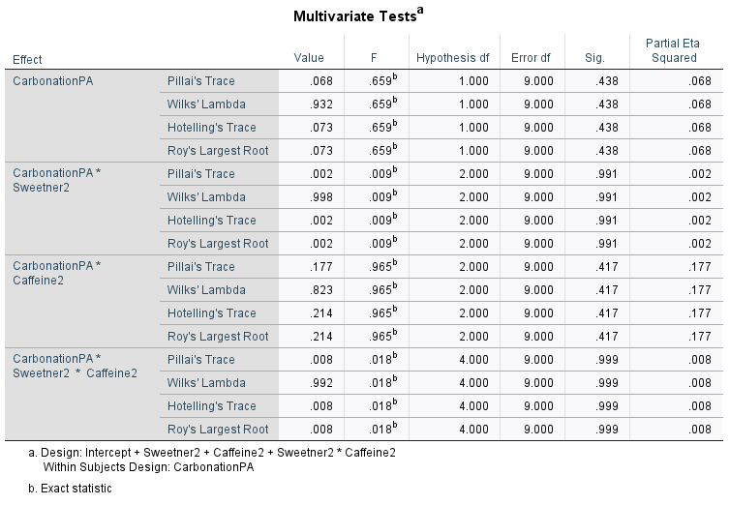

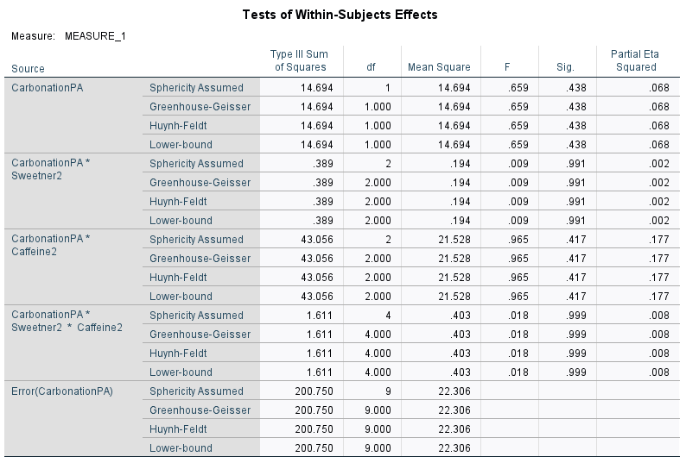

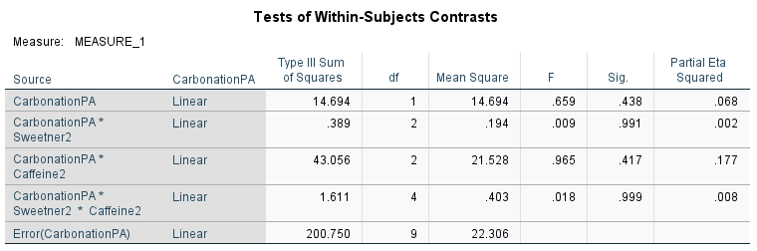

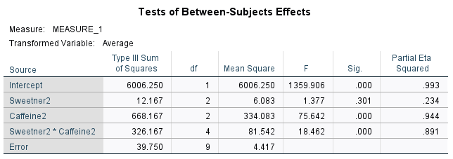

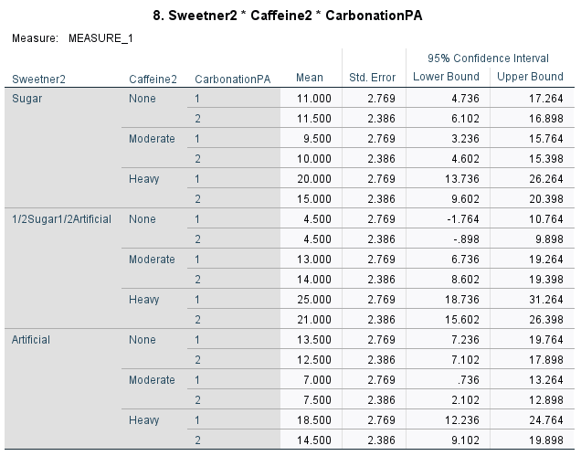

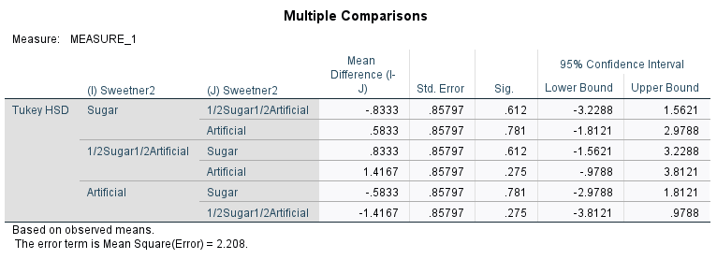

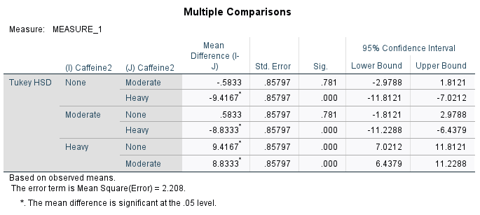

How does the analysis change?

The analysis changes because test of within subject effect was generated, test of within subject contrast was generated in addition to the test of between subject effects. However, in the test of between subject effect, only caffeine and interaction between caffeine and sweetener was significant as earlier reported.

Does your interpretation change?

No, my interpretation remains the same. Because there was no any level of significance form within subject effects that could change my earlier interpretations.

Questions 3 & 4:

A teacher wants to increase interest in STEM careers in middle school students (research has shown that this is a key time frame to introduce potential career paths). The teacher decides to test different types of STEM presentations to a group of boys and girls. The teacher gives the student a short questionnaire about careers in science before and after the presentations to assess the children’s initial and subsequent views on STEM careers. The teacher presented students with either a professionally made video, another teacher, or an actual practicing STEM professional.

* Run a mixed factorial design (with pre/post as the repeated) measure and interpret the results of the analysis.

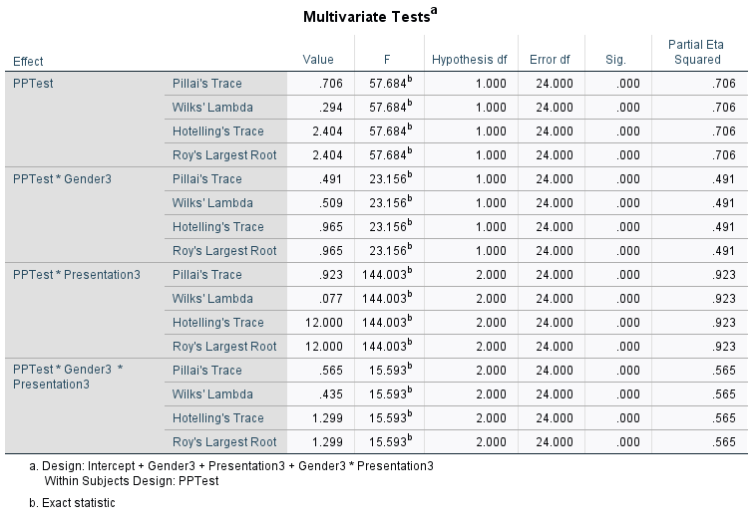

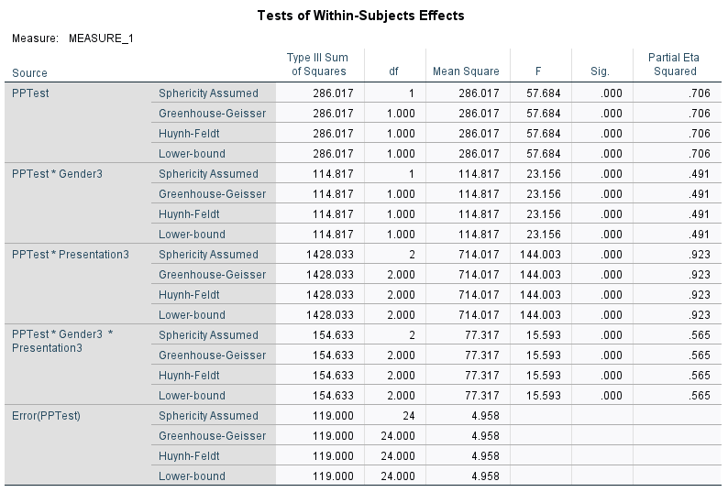

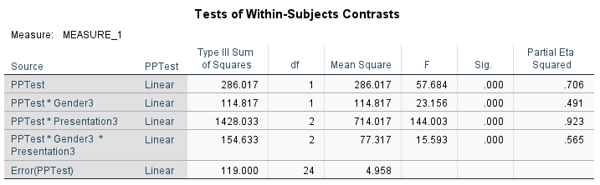

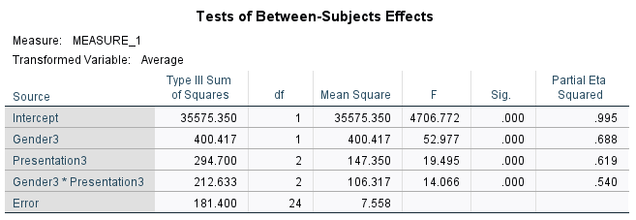

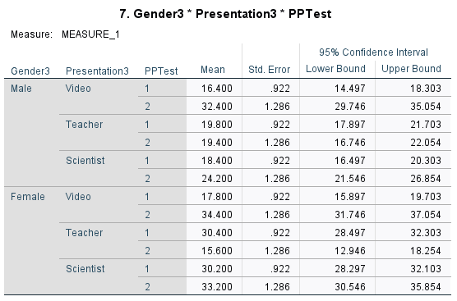

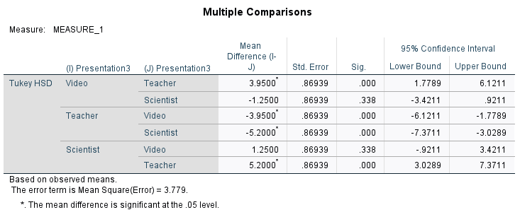

**Part 2: Question 3: Interpretation**

A mixed factorial analysis was conducted to investigate how gender (male or male), test (pre and post), and different presentations method influences middle school students’ interest in STEM. The means and standard deviations for the learning recall are presented in Table 2.2 below. From within subject effects, the result of the analysis indicated a significant main effect for test, *F*(1,24) = 57.684, *p*(0.000) < 0.05, partial ɳ2 = 0.706. likewise, from between subject effects, there was a significant main effect for gender, *F*(1,24) = 52.977, *p*(0.000) < 0.05, partial ɳ2 = 0.688. Also, there was a significant main effect for presentation methods, *F*(2,24) = 19.495, *p*(0.000) < 0.05, partial ɳ2 = 0.619. Interms of interaction, there were significant interaction effects from both within and between subject effects. From within subject effects, there was a significant interaction effect for test and gender, *F*(1,24) = 23.156, *p*(0.000) < 0.05, partial ɳ2 = 0.491. Also, there was a significant interaction effect for test and presentation, *F*(2,24) = 144.003, *p*(0.000) < 0.05, partial ɳ2 = 0.923. At the same time, there was a significant interaction effect for test, gender and presentation, *F*(2,24) = 15.593, *p*(0.000) < 0.05, partial ɳ2 = 0.565.

Table 2.2. Mean and Standard Deviation for Question 3

|  |  |  |  |  |
| --- | --- | --- | --- | --- |
| Test | Gender | Presentation | M | SD |
| PreTest | Male | Video | 16.4000 | 1.94936 |
| Teacher | 19.8000 | 1.30384 |
| Scientist | 18.4000 | 2.07364 |
| Female | Video | 17.8000 | 2.16795 |
| Teacher | 30.4000 | 2.70185 |
| Scientist | 30.2000 | 1.92354 |
| PostTest | Male | Video | 32.4000 | 1.81659 |
| Teacher | 19.4000 | 3.04959 |
| Scientist | 24.2000 | 1.64317 |
| Female | Video | 34.4000 | 2.07364 |
| Teacher | 15.6000 | 4.61519 |
| Scientist | 33.2000 | 2.94958 |

Because the interaction between test, gender and presentation was significant, we chose to ignore the test main effect and instead examined the test simple main effects - that is, the difference among pretest and posttest. Referring to the mean table above (Table 2.2), it is obvious that female that took the posttest questionnaire and watch the video presentation are more like to show more interest in STEM. Also, female that are present in the scientist presentations both during pretest and posttest and also took both pretest and posttest questionnaires are more likely to have more interest in STEM.

* Run these data with the pretest as a covariate (ANCOVA) and interpret the results of the analysis.

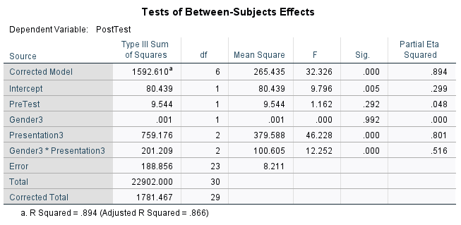

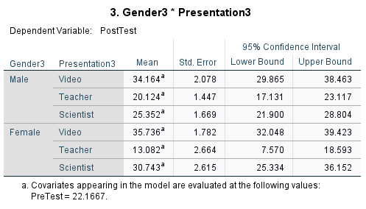

**Part 2: Question 4: Interpretation**

Analysis of covariance (ANCOVA) was conducted. The independent variables, gender, included two levels: male and female and presentation, included three levels: video, teacher, and scientist. The dependent variable was taken to be the posttest and the covariant was the pretest. The output of the analysis indicated that the relationship between the covariate (pretest) and the dependent variable (posttest) was significant as a function of the independent variables (gender*presentation), F(2, 23) = 12.252, p(0.000) <0.05, partial ɳ2 = 0.516. likewise, the relationship between the dependent variable and presentation was significant, F(2, 23) = 46.228, p(0.000) <0.05, partial ɳ2 = 0.801. We could notice that the strength of relationship between the presentation and dependent variable was very strong, as assessed by a partial ɳ2, with the presentation factor accounting for 80% of the variance. However, after accounting for covariant, the relationship between the dependent variable and gender was nonsignificant, F(1, 23) = 0.000, p(0.000) <0.05, partial ɳ2 = 0.00. The means of the posttest adjusted for presentation indicated that, female that watch video and engaged in posttest are more likely to show interest in STEM (M= 35.74), followed by male that watches video (M = 34.16).

* How does the outcome/interpretation of these data change between the two analyses?

The outcome of this analysis makes it possible to find the relationship between the dependent variable and the independent variable while keeping covariant factor constant.

* Which approach do you think is more appropriate (and why)?

ANCOVA approach is appropriate because it help to better understand how a factor impacts a dependent variable (DV) after accounting for some covariate(s).

Questions 5 & 6:

A researcher wants to examine the potential benefits of diet and exercise on two commonly used markers of health, weight and cholesterol levels. Participants were assigned to one of four combinations of diet/exercise (2 x 2) and had their weight (pounds) and cholesterol (LDL) measured.

* Run as a factorial design with a covariate (weight) and interpret the results.

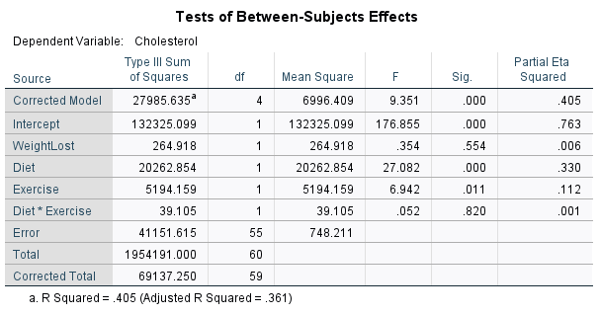

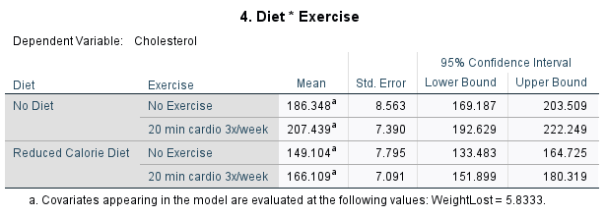

**Part 2: Question 5: Interpretation**

Analysis of covariance (ANCOVA) was conducted. The independent variables, diet, included two levels: no diet and reduced calorie diet, and exercise, included two levels: no exercise and 20 min cardio 3x/week. The dependent variable was taken to be the cholesterol and the covariant was weight. The output of the analysis indicated that the relationship between the covariant (weight) and the dependent variable (cholesterol) was nonsignificant as a function of the independent variables (diet*exercise), F(1, 55) = 0.052, p(0.820) > 0.05, partial ɳ2 = 0.01. However, the relationship between the dependent variable and exercise was significant, *F*(1, 55) = 6.942, p(0.011) <0.05, partial ɳ2 = 0.112. Furthermore, after accounting for covariant, the relationship between the dependent variable and diet was also significant, F(1, 55) = 27.082, p(0.000) <0.05, partial ɳ2 = 0.330. The means of the weight adjusted for the cholesterol indicated that, reduced calorie diet with 20min cardio 3x/week, yields a lesser and more reasonable cholesterol reduction (M = 166.11).

* Run as a MANOVA with weight and cholesterol as the dependents and interpret the results.

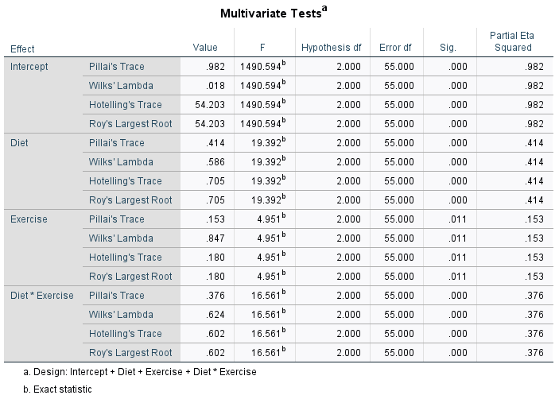

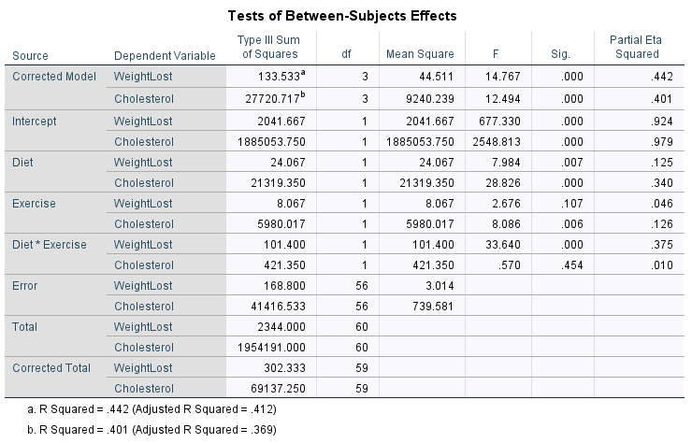

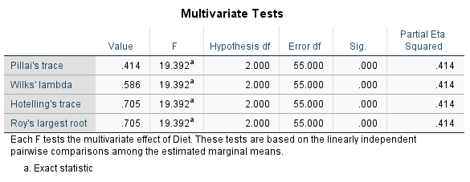

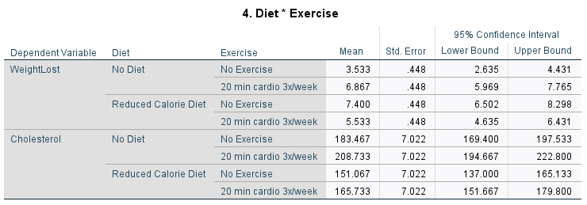

**Part 2: Question 6: Interpretation**

A multivariate analysis of variance (MANOVA) was conducted to determine the effect of diet (i.e., no diet or reduced calorie diet) and exercise (i.e., no exercise or 20 min cardio 3x/week) on two dependent variables, weight loss (kg) and Cholesterol (LDL) level. A significant differences were found among the two factors and their levels on the dependent measures, Wilks’s **˄** =0.586, *F*(2, 55) = 19.392, *p* < .05. The multivariate ɳ2 based on Wilks’s **˄** was quite strong, 0.414. Table 2.3 below contains the mean and standard deviation on the dependent variable for the two factors and their level.

**Table 2.3:** Means and Standard Deviations on the Dependent Variables for Each Factor/Levels

|  |  |  |  |  |  |
| --- | --- | --- | --- | --- | --- |
| Diet | Exercise | Weight Lost | | Cholesterol | |
| M | SD | M | SD |
| No Diet | No Exercise | 3.5333 | 1.64172 | 183.4667 | 34.52508 |
| 20 min cardio 3x/week | 6.8667 | 1.76743 | 208.7333 | 25.42908 |
| Reduced Calorie Diet | No Exercise | 7.4000 | 2.09762 | 151.0667 | 26.11094 |
| 20 min cardio 3x/week | 5.5333 | 1.35576 | 165.7333 | 20.92663 |

Analysis of variance (ANOVA) on the dependent variables were conducted as follow-up tests to the MANOVA. Each ANOVA was tested the 0.05 level. The ANOVA on the weight lost with respect to diet was significant, *F*(1, 56) = 7.984, *p*(0.007) < 0.05, ɳ2 = 0.125 level, likewise, the ANOVA on the cholesterol with respect to diet was significant, *F*(1, 56) = 28.826, *p*(0.000) < 0.05, ɳ2 = 0.340 level. However, The ANOVA on the weight lost with respect to exercise was nonsignificant, *F*(1, 56) = 02.676, *p*(0.107) > 0.05, ɳ2 = 0.046 level, but, the ANOVA on the cholesterol with respect to exercise was significant, *F*(1, 56) = 8.086, *p*(0.006) < 0.05, ɳ2 = 0.126 level. In term of interaction between diet and exercise, The ANOVA on the weight lost with respect to the interaction was significant, *F*(1, 56) = 33.640, *p*(0.000) < 0.05, ɳ2 = 0.375, while the ANOVA on the cholesterol with respect to the interaction was nonsignificant, *F*(1, 56) = 0.570, *p*(0.454) > 0.05, ɳ2 = 0.010.

Post hoc analyses consisted of conducting pairwise comparison to find which combination of diet or exercise practices enhances weight lost or cholesterol reduction most strongly. Reduced calorie diet and 20 min cardio 3x/week enhances weight lost and cholesterol reduction compared to other combinations of practices (see Table 2.6 above).

How does this interpretation differ from question 5?

In question 5, covariant was accounted for and the only one dependent variable (cholesterol) was under consideration. However, in this question two dependent variables are being considered (weight and cholesterol).

Should it differ?

Yes, because they the are two separate analysis, one is testing covariant (ANCOVA) and the other testing for multiple dependent variable (MANOVA).